WEB FORUM CRAWLER

A project presented to the
Department of Computer Science
University of Nebraska at Omaha

In Partial Fulfilment of the Requirements for the Degree

Apr 16th, 2015

SUPERVISORY COMMITTEE
Dr. Zhengxin Chen (Chair)
Dr. Sanjiktha Bhowmick
Dr. Dhundy Bastola

PREPARED BY
Mohan Reddy Kanthi

Abstract
Internet has been the best innovation of the millennium with which today people across the globe are performing most of the work online and are able to find the solutions to problems by just a click away. Online web forums play an important role in providing solutions to many problems in various fields by mutual sharing of information. The Forums has vast information from many users in the form of thread pages it would be best if we have a solution to get the relevant pages in short amount of time. Even though forums can be built using different software packages, it is imperative how similar navigation path would flow from entry page to index page and finally to thread pages, where user can find the detailed required information in all of the web forum pages. Web crawlers play an important role for search engines in finding the relevant information from the web forum pages.
This research’s main focus would be on developing a crawler, which efficiently gathers relevant information by reducing the forum crawling problem to URL type recognition problem and revising the crawling steps by FoCUS [15] by crawling the forum in parallel with the learning process. The proposed crawler analyses page classifiers from as few as 3 and can be applied to many unseen web forum during crawling process. The paper’s secondary focus would be on how to retrieve all possible navigation paths of a particular page which can be used in identifying the optimal navigation path to that particular thread page.

Contents
Abstract 2
1. introduction: 4
1.1 Aim 5
1.2 Deliverable 5
1.3 Research Question(S) 6
1.4 Challenges Faced 6
1.5 Main Reference 7
2. LITERATURE REVIEW 9
2.1 Web Forums 9
2.2 Web Crawler 10
2.3 HTML DOM 13
3. academic value 14
3.1 Information Storage & Retrieval 14
3.2 Design Algorithms 14
3.3 Database Management System 15
3.4 Software Specification & Design 15
4. High level details 17
4.1 Block Diagram of the Project 17
4.2 Program Flow 18
4.3 Requirements 20
4.3.1 Hardware Requirements 20
4.3.2 Software Requirements 20
5. IMPLEMENATATION 21
5.1 Constructing URL Set 21
5.2 Page Type Classification 23
5.3 Online Crawling 24
5.4 Entry URL Discovery 25
5.5 Navigation path 26
6. EXPERIMENTS COnDUCTED & ANALYSIS 27
6.1 Crawling Effectiveness Comparison 28
6.2 Crawling Coverage Comparison 29
6.3 Large Scale Online Crawling 31
6.4 Source Page/Navigational path evaluation 31
7. CONCLUSION 33
REFRENCES 34
APPENDICES: 38

introduction:

The rapid proliferation of the Internet and the World Wide Web led to an explosion of easily accessible information. Such information is contained in web pages. The magnitude of information available on the World Wide Web is so large that retrieving required information from the web pages becomes a challenge. This Challenge is compounded by the fact that the nature of information in these web pages is heterogeneous and diverse. Most of the information can be accessed only through a search engine.
Web search engines search the web sequentially and methodically based on the “Key words” or the “queries” entered by the user. Search engines have web crawlers that download web pages and create a repository in the search engine. The number of pages downloaded by a web crawler could run into millions. The repository so created is used by the search engines to retrieve web pages. The repository is indexed. The queries as entered by the user are run against the index to retrieve matching web pages.
Web crawlers are important because they create a corpus of web pages and index them. Such organization is important because the web is a heterogeneous collection of diverse web pages. No one ‘manages’ the web. A web crawler starts with an initial URL, called the seed, and downloads all the web pages addressed by the URL. It also extracts hyperlinks from the web pages. It then downloads the web pages addressed by the hyperlinks. The process continues iteratively. Although the process of web crawling sounds very simple, there are several challenges associated with it. One of the biggest challenges is downloading a large number of pages. Given the fact that the web contains billions of a crawler to create repository that is a mirror image of the web. Compromising on the number of web pages in the repository means compromising on the quality of search results. This problem is further compounded by the fact that the web pages are updated continually which means that fresh versions of webpages already present in the repository have to be reloaded. Thus, there is always a trade of between coverage and freshness.
Although a web crawler can Crawl’ or visit URLs in any order, the order in which it visits the web pages is important. No web crawler can claim to have crawled the entire web, for, new web pages keep on adding and old pages get updated. Thus, the iterative process of web crawling is infinite. Based on the order in which web pages are downloaded into the repository, crawlers can be classified into the traditional breath – first crawling and Broad form crawling. As stated earlier, the crawling process is infinite. It is never possible to create a repository that is a mirror image of the web. There is always scope for implementing new and innovative crawling algorithms, since all the existing crawling algorithms suffer from one disadvantage or another.

Aim
The aim of the research is to:
- Study and understand efficient crawling techniques and their algorithms.
- To revise the current crawling techniques.
- To display appropriate web crawling results, along with the classification of forum pages, when the user enters the URL
- To display the navigational path of the forum sites. This navigational path is useful to extract information from the site and to fast track the pages.

1.2 Deliverable
The product which would be developed is a distributed web crawler which will crawl the given website forums. It will also display relevant forum pages classified by entry, index, thread and page flipping URL’s. The crawler also has the ability to retrieve the navigational path to find a particular URL of web forum. The web forum pages will be identified based on the default classifiers. It also allows the user to reconfigure the default classifiers and start the crawling process.

1.3 Research Question(S)
- Investigate into web crawling in data mining and how Java supports crawling of website forums?
- Investigate into the concept of crawling in web forums and how Crawling could be implemented through data mining in Java?
- Investigate into the concept of storing and processing of huge amount of forum data to be used while during the crawling process?
- Investigate into concept of web learning and how to generate regular expressions for web forum sites by using Java?
- Investigate into the concept efficient knowledge extraction from the data extracted by the web forum crawlers?

1.4 Challenges Faced
- The biggest challenge I faced during the project development phase was to determine the optimal list of classifiers to be used in determining a page type from as few as 3 software forum packages.
- Configuration of Java web crawling engine in my machine for initial testing because I did not have access to run the code on the University servers for most part of my project.
- Implementation of index/thread URL detection algorithm and page flipping URL Detection algorithm.
- Handling/downloading huge amount forum page data in the program made java runtime to go out of memory errors.

1.5 Main Reference
The research paper FoCUS: Learning to Crawl Web Forums by Jingtian Jiang, Nenghai Yu† and Chin-Yew Lin (2013) is one of the main reasons to work on this project.
In my research project, I have implemented a couple of algorithms like index/thread URL detection, Page Flipping and also Entry URL discovery algorithms, which were described in the above paper. I have also revised the FoCUS crawling process and added new features to the crawler.
Below are some of the major differences/process improvements from the main reference [15] to my research,
- Even though FoCUS was efficient in crawling process, the major drawback I found was the hitting all the pages of the forum during the learning phase and also crawling phase. It is taking an extra amount of time in hitting huge number of web pages twice so what I made was to process the 2 modules in parallel which saves space and time of the program.
- FoCUS used SVM light 6.02 version of support vector machine learning software to pass the page classifiers to identify the page types in the forums. The Crawler from the research paper used a simple classifier library which can do basic comparison functionality to determine the page type.
- The important extra useful information which this forum crawler is providing apart from the various relevant forum pages are 1) the navigational path information about each page. 2) The number of times that any particular URL type appeared on the all of the forum pages.
- The number of page classifier considered for this forum are reduced from 7 to 4 and also the training software package forums chosen to analyze are reduced from 5 to 3. This process is made manual in choosing the software forum packages in analyzing page classifiers for the crawler where in the FoCUS takes any 5 annotated forum packages.

LITERATURE REVIEW

Web Forums
The internet has facilitated the formation of online communities that collaborate and discuss with each other. There are both open and closed community collaboration systems. While participation in closed collaboration systems is restrictive, open collaborative systems encourage free communication and exchange of content ((Breslin et.al, 2006)
The open collaborative communities have become so popular that they could replace traditional information sources (McArthur and Bruza, 2001), because they allow better communication and exchange of ideas amongst the members of the community (Wellmann and Gulia, 1999).
Advances in technology, especially the development of Web 2.0, paved way for an explosion of user created content (UCC) on the Web. There are different forms of UCCs, but the most popular of them are the Web forums. There are innumerable Web forums that are used by millions to create and share content; the content on the web forums represents “a tremendous collection of human knowledge, and therefore is highly valuable for various Web applications”(Cai et.al.,2008).
The popularity of web discussion forums can be attributed to the fact they allow users to interact with each other and facilitate discussions; they are easier to use and have more functionalities than newsgroups (Limanto et.al., 2005).
An internet forum has several sub-forums, each devoted to a particular topic. Users can post their opinions on any of the topics. Whenever a new topic is initiated by a user, a new “thread” is created. Other members can post their opinions on this thread. Thus, a web-forum has several sub forums, which in turn have many threads. This gives rise to the ‘hierarchical’ or ‘tree’ structure of a Web forum (Thirumoorthy & Jothi. 2014).
Web forums usually contain three types of pages- entry, index and thread. The entry page is the “home page” which contains the list of sub-forums. An index page contains the list of threads in a sub-forum, while the thread page contains posts by the members (Thirumoorthy & Jothi, 2014).

Web Crawler
Web crawling has attracted the attention of several researchers. Finding an efficient way to web crawling has become all the more important for mining precious data from the web. The potential benefits of searching for valuable information from the web pages has made web crawling a hot topic of research.
A Web Crawler consists of three components: a frontier, a page downloader and a web repository. The crawler frontier maintains a list of URLs that have not yet been visited by the crawler. The crawler starts working from the frontier by retrieving an URL (the ‘seed’) from the list and fetching the web page. The list of URLs from the web page so fetched is added to the frontier. This process of extracting URLs and fetching web pages continues till the frontier is empty (Pant & Srinivasan, 2005).
The Page downloader, as the name suggests, downloads pages whose URLs were extracted from the frontier into the web repository which stores the web pages in form of objects, just like file systems and database management systems . Web repositories store only HTML pages and ignore other document types (Hirai et.al.,n.d).
There are several types of crawling techniques like focused, broad forum, iRobot etc. A Focused Crawler focuses on a particular topic and tries to download webpages that are related to the topic and to each other. Because of its emphasis on a particular topic, it is also known as a ‘Topic Crawler’ (Mali & Meshram 2012). A focused crawler evaluates how relevant the web page in question is to the given topic before downloading the page (Hati, Sahoo & Kumar, 2010).
Ntoulas, Zerfos and Cho (2004) studied the problem of crawling deep/hidden web. Hidden web pages do not have static links, and hence a search engine cannot find the hidden pages even if the keywords entered by the user are contained in such pages. However, hidden web pages may contain valuable information that could be beneficial to the users. The researchers proposed a three step algorithm to crawl the hidden – decide which query term to use, issue the query, retrieve index page and download hidden web pages. According to the authors, this is a very efficient algorithm, and it helped them download more than 90% of hidden web pages in an experiment.
Pandey and Olston (2005) studied web crawling from a user-perspective. They argue that since the web is dynamic, the local indexed repository of search engines are rarely in synchrony with the ever changing content of the web pages. Such lack of synchrony leads to a deterioration of query results. To overcome this problem, the researchers suggest that resources should be allocated to give users a good experience and that scheduling should not depend on external tuning parameters, rather it should be based on the frequency of queries and results that interest users.
Repository freshness is an important factor that determines the efficiency of any web crawling. The more updated the repository is, the more efficient is the crawling. However, given the dynamic nature of the web, it is impossible to maintain its replica in the repository (Ntoulas, Zerfos & Cho, 2004), which leads to sub-optimal quality of search results.
Wolf et.al, 2002 studied the problem of lack of synchrony between the web pages and the search engine repository. They propose that reducing the ‘average staleness’ of the web pages in the repository is an ideal strategy to keep the repository fresh and maintain the quality of search results.
Wolf et.al (2002) also proposes a new metric, embarrassment, to determine the efficiency of web crawling. An embarrassment is thought to have occurred whenever a user clicks on a search result, and when the search result turns out to be wrong or inappropriate.
Board forum crawling follows a structured method to crawl the web, by starting from the home page and then following the board page seeds. Subsequently, it follows the page-flipping links. Finally, user posts are extracted from the page-flipping links (Guo et.al., 2006).
iRobot is an intelligent Web Forum Crawler that understands the structure of the web form and devices traversal paths in such a way that duplicate pages are skipped. Recreation of the site map and development of traversal paths takes place offline in which region-based clustering, sub-clustering of URLs takes place (Cai et.al, 2008)
Depth First Search Algorithms start at the root node and traverse deeper through the child node. These algorithms give priority to the left-most node, and traverse till all the nodes are exhausted. Once all the children of a node are crawled, it backtracks and visits the next node and repeats the process (Shen, 2010)
A Page rank algorithm counts the citations to a given web page and determines its relative importance (Brin & Page 2004).

HTML DOM
A web page is essentially a document that can be stored in different ways. The Document Object Model provides for storing web pages in as objects. Storing web pages as objects allows us to manipulate the content and structure of web-pages by enabling different programs to access the document’s structure. It defines the logical structure of documents and makes it easy for programmers to not only build documents, but also to add, delete and modify elements. The DOM is an application programming interface for HTML documents and XML documents.
Documents in DOM have a “tree” structure, which is also referred to as “structure model.” The documents are stored as objects, and as such, have both structure and behavior of a document. The DOM also provides for collaboration between interfaces and objects. The objects are stored in DOM as a hierarchy of nodes. Some nodes have child nodes, while others do not. The nodes that do not have children are called leaf nodes.

academic value

I needed the right kind of analytical knowledge to analyze various algorithms from my base paper, focus [15] and good amount of technical knowledge to implement the existing and new algorithms in a best way possible. My course work at the College of Information Science and Technology at the University of Nebraska, Omaha, has helped me gain sufficient knowledge in different areas of information technology. The knowledge that I acquired during my 3 semesters of study in the University has helped me a lot in analyzing algorithms. Specifically, the following courses helped me in planning, designing and implementing this project:

3.1 Information Storage & Retrieval
This course is one of the primary reasons in selecting this kind of project. The web crawlers are basically the data source gatherers to be used for the Indexers of the search engines. Search Indexer creation with a predefined set of web documents is primary project of this course. I have always wondered what will be the application which generates these documents dynamically and updates periodically. The idea to develop an application which collects data for an indexer formed basic motivation to develop this web forum crawler.

The concepts that I learned in this course laid a solid foundation for this project. This course helped me to understand how information is indexed, represented, stored and retrieved from information systems. Discussions on topics like models of information storage and retrieval, document processing and evaluation of system hardware have also helped me in successfully completing this project. The most important take away from this course was the deep insights that I gained into programming with Core Java while working on a project to develop a search indexer.

3.2 Design and Analysis of Algorithms
Understanding and implementation of algorithms plays a crucial role for any application or product development. This project is based on understanding of existing algorithms like index/thread URL detection, Page Flipping and also Entry URL discovery algorithms from my base paper. This course enabled me to gain knowledge of algorithms, their design and analysis. The performance of any application depends on the type of data structures or primitive algorithms used to handle various data types in the application. This course I also learned about different types of algorithms like graph algorithms, practical data structures (heaps, hash tables, search trees), randomized algorithms etc.

Since web crawlers depend on algorithms to visit URLs and download web pages, knowledge of algorithms is very essential to design a web crawler. Different crawlers follow different strategies to visit URLs (e.g. breadth-first, focused etc.). The design of algorithms differentiates one web crawler from another. Pursuing this course definitely made a difference in the implementation of the project.

3.3 Database Management System
This is one of 3 database management systems courses I have took had an enormous impact on how am handling various kind of data for an application or a project. This course covered with lot basic concepts of databases which played an important part in the completion of this project. The Storing of crawled web forums is a vital module in the implementation of this project. A web crawler downloads web pages and stores them in a data base. The number of web pages stored could run into millions. So, the database should be designed properly to efficiently store and retrieve information.
This course has helped me to understand concepts like relational models, data modelling, SQL, database administration and security, database design, normalization theory etc.

3.4 Software Specification & Design
The success of any software project depends on efficient planning, creating, testing, and deploying. This course has helped me to understand the early phases of software development, particularly requirements gathering. I also understood the different phases of Software Development Life Cycle. This course also helped me in read and write formal specifications of any existing software’s used during the project.

The Software Requirements Specification document that I created for a project that I did in this course helped me to describe the software system being developed, to list the functional and nonfunctional requirements. It helped me to visualize what the system is supposed to do and not to do. It also helped me to plan, identify risks and estimate costs. Apart from the understanding the various requirements during the development cycle this course helped in creating a documentation for an application or a project. The thorough understanding of requirements saved a lot of time by reducing the need to redesign the system.

High level details

4.1 Block Diagram of the Project

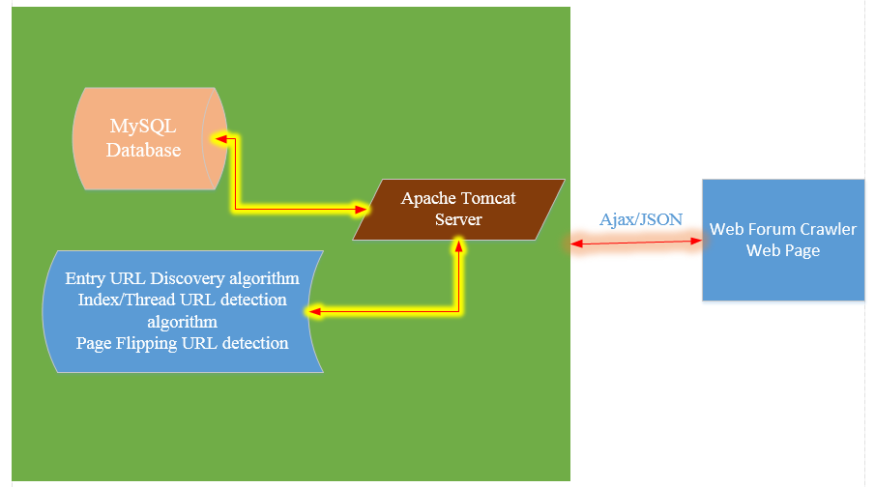
Fig 1.Block diagram of the project

Figure 1 illustrates the high level architecture of the project. User accesses the Web Forum Crawler page on browser and provides a forum URL to be crawled to the server, where crawling process is executed. The requests to the server, Apache Tomcat server are through HTTP requests using AJAX/JSON. Apache Tomcat communicates with MySQL database for the user, classifiers related information and also retrieve the saved web forum crawled pages to be used by one of the page detection algorithms. It also connects to the application, where the algorithms (Entry URL discovery, Index/Thread URL detection and Page Flipping URL detection algorithms) are executed and serves the results back to user logged in on the web page in the form of JSON.
The authorized database personnel or database administrator is the only user who can access the database directly MySQL database manager at the server to manage and maintain the database.

4.2 Program Flow
Theoretical parts of the research are gathered in depth through qualitative research methodology but findings are possible only when experimental based methodologies are chosen. Empirical research methodology is of that type which would gather findings with an experimental based research. To try based on an experiment the total Java environment has to be setup and the system has to be implemented which would have the functionalities of load Metadata of a provided URL link, crawl the underneath links of URL, computing page rank and indexing all the links etc.
- Take input forum URL to be crawled from the user
- Load the Classifier configurations
  - By Default below configurations are loaded or also these are configurable by user at any point of time before the crawling starts
    - Valid Link Count = 20 (Minimum for Index page)
    - Anchor Text length = 50 (Majority of Links should have more than 50 for Index Page)
    - Plain Text Length = 100 (Maximum of 100 chars in a row of URL in the Index Page)
    - Has User Link = False (Index page should not have user post link)
- Find the Entry URL from the URL given using the Entry URL discovery algorithm described in the section 4.5
- Find the base URL from the Entry URL which will be used in validating URL’s later and also used in forming the base part of URL if the URL is partial
- Get HTML DOM of the Entry page using Entry URL above
- Add Entry URL into a Queue and insert the details about the Entry URL from its HTML DOM into database or repository. In this case repository is MySQL database
- Until the Queue is empty do repeat the below process
  - Get the URL from the Queue
  - Get the HTML DOM of the retrieved URL from the queue
  - Based on the classifiers defined, the source page of the URL and the Index/Thread URL detection algorithm described in the section 4.2 find the page type of the URL using its DOM object
    - If the above algorithm return empty which mean it is not index or thread page then Pass the DOM through the Page Flipping URL detection algorithm to determine if it is page flipping URL
    - Update the database based on the return value of the page flipping URL detection algorithm
  - Get all the links from the DOM object above and validate each link against the base URL above. If the validation fails ignore the link and go to the next link in the DOM
  - Form the URL if it partially complete
    - Example: /categories to www.forums.robotstudio.com/categories
  - If the validation returns true and complete URL is formed, check if the URL is already available in the database/repository
  - If it is not present, then consider it as first time and store it in the database
  - Else add get the URL details from the database add count and other details and finally update the database record again
- After the data retrieved is stored into the database, retrieve the results back to the user based on the user query

4.3 Requirements

4.3.1 Hardware Requirements

- System : Pentium IV 2.4 GHz.
- Hard Disk : 40 GB.
- Floppy Drive : 1.44 Mb.
- Monitor : 15 VGA Colour.
- Mouse : Logitech.
- Ram : 512 Mb.

4.3.2 Software Requirements

- Operating system : Windows XP/7.
- Coding Language : JAVA/J2EE
- IDE : Eclipse
- Database : MYSQL

IMPLEMENATATION

In this implementation section discuss about implementation of web crawling engine system. The system consists of below modules coordinated to form an efficient crawler system. All the modules of the system are developed using JAVA programming language. The first section describes the process/steps of the crawler from the user initialization to returning the results.
The following modules are in this system
- Constructing URL Set
- Page Type Classification.
- Online Crawling
- Navigational path.

Modules Description

5.1 Constructing URL Set
This is the first process that gets executed when the user enters URL (entry page) to crawl a web forum. The goal of training set construction is to automatically create sets of highly precise index URL, thread URL, and page-flipping URL string samples to be used by another parallel process, which is online crawling (see section 4.3 below).
This process calls the Page Type Classification (see section 4.2 below) after preprocessing/cleaning the URL. This gets the DOM object of the cleaned URL type by opening a HTTP connection and the DOM is passed to the Page Type classification process to determine the page type based on the classifiers defined. Queue is important data structure used in handling the data during the recursive process of the algorithm.
Index and Thread URL detection algorithm takes entry page as input and generates index and thread URL by recursively calling the same functionality until there are no URL’s are left in the Queue.

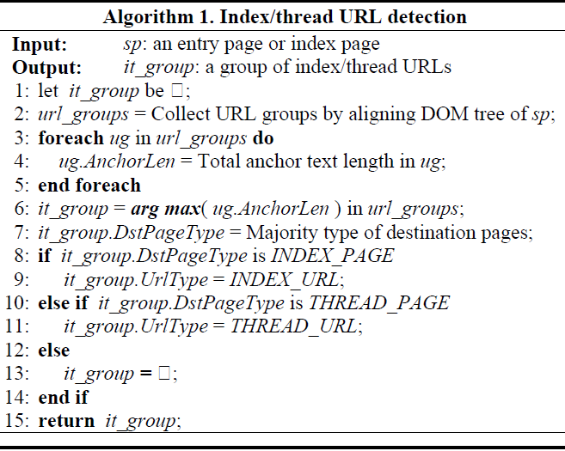
Fig.4.1.The picture illustrates the steps of Index/thread URL detection (Jingtian Jiang, 2013)

Page-Flipping URL detection algorithm takes page from above implementation as input and generates Page-Flipping URL’s by recursively calling the same functionality until there are no URL’s are left in the Queue.

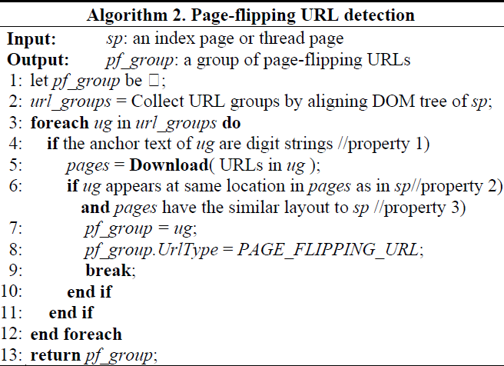
Fig.4.2.The picture illustrates the steps of Page-Flipping URL detection (Jingtian Jiang, 2013)

5.2 Page Type Classification
This is the core module which determines the page type for all the other algorithms. Page type classifiers are the attributes on which the page is classified. Analyzing the page type classifier is a manual process where we need to understand the structure of the forum pages from various software forum packages. In this research I took 3 software forum packages from which I generated the below page classifiers to be used by the crawler for page type identification.
Below are the 3 software forum packages used for generating the classifiers manually
- vBulletin is a proprietary Internet forum software package developed by vBulletin Solutions. It is written in PHP and uses a MySQL database server
- Exo Platform is an open source, standard-based, forum software package written in Java.
- Discourse is open source Internet forum software application written in JavaScript and Ruby on Rails.
The reason for picking above software for determining the classifiers is that to have the best software forum package written in 3 different types of programming languages. Below are 4 optimal classifiers short listed from FoCUS and also identified from the 3 software forum packages mentioned above.

Classifier Name | Value Type | Short Description
Valid Link count | INTEGER | Number of valid URL links on a forum page
Anchor Text Length | INTEGER | Anchor length of each URL link on a forum page
Plain Text Length | INTEGER | Anchor length of each URL link on a forum page
Has User Link | Boolean | Check if the row as a user profile link at the end

5.3 Online Crawling
This Module is executed in parallel to the construct URL set process where each URL generated and identified is passed to this process for crawling. This reduces the burden of hitting web forums pages twice as the number of links in a web forum can be huge and thus it may cause performance bottleneck.

5.4 Entry URL Discovery
This is the important algorithm which has major impact in the efficiency of the crawler when the user has given non-entry URL has input to the crawler. It is understood the majority of previous crawler which doesn’t have the algorithm to determine the Entry URL has always starts at whatever URL given and which mostly results in dip in precision and recall results of the crawler.

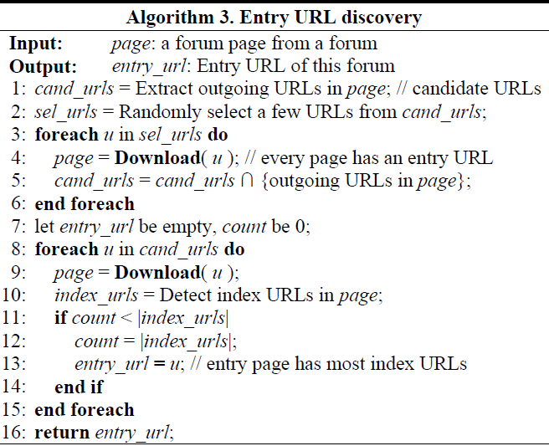
Fig.4.3.The picture illustrates the steps of Entry URL Discovery (Jingtian Jiang, 2013)

5.5 Navigation path
This is an additional independent process which provides the important information regarding the individual URL’s of a web page. The basic functionality of this process is to retrieve the navigational path from the entry page to the target page for each page of the forum.
This is achieved by the use data saved during the other modules execution where we save all the source page, target page and the count of the page in the forum.

EXPERIMENTS COnDUCTED & ANALYSIS
All the experiments conducted in this paper are to evaluate the performance of the system in terms of correctness rather than time. This is widely due to the different processor/memory configuration used by FoCUS and this crawler (see below for reference).
FoCUS ran on a machine with 4-core 2.20 GHz CPUs, 32 GB memory, and 64-bit Windows server 2008 SPI OS whereas the crawler implemented in this project ran on 2-core 2.5 GHz CPUs 4GB memory, and 64-bit Windows 7 OS. To speed up the Experiment process I have also used the crawler to run on different system with almost same configuration as it might take more than 2 hours of crawling to process more than 5 lakhs of thread pages. The individual modules precision and recall values can be referred to focus [15] as this crawler is using exact algorithms for the modules Index/Thread detection, Page-Flipping detection and Entry URL discovery algorithms.

In this section we will discuss on detailed analysis of this Crawler and its implementation with FoCUS. Below are the evaluations done against FoCUS to compare the correctness of the crawler,
Index | Experiment
6.1 | Crawling Effective Comparison
6.2 | Crawling Coverage Comparison
6.3 | Large Scale Online Crawling
6.4 | Source Page/Navigational path evaluation

Except the 4th forum (http://bbs.cqzg.cn/), which might be down recently or URL got changed and as its HTML DOM cannot be accessed I used all the remaining 8 forums from the below table and are used in evaluating sections 6.1, 6.2 and 6.3. I use the results from the FoCUS for these forums and compare that with the Crawler implemented for this project.
I am using the effectiveness and coverage metric defined by the FoCUS [15] to evaluate this crawler against the FoCUS. These metrics are defined in the sections 6.1 and 6.2 respectively.
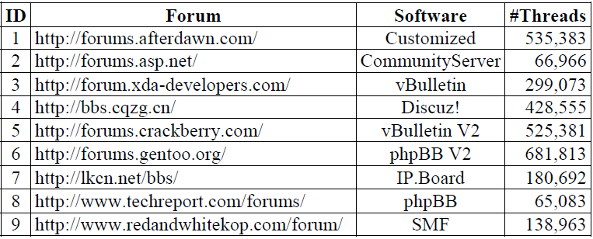
Fig.5.1.The table shows the forums used/ result threads by FoCUS for online crawling evaluation

6.1 Crawling Effectiveness Comparison
I used the effectiveness measure and applied them on the forums above to evaluate this section and compared the results with that of FoCUS. Effectiveness measure is explained as below
Effectiveness measures the percentage of thread pages amoung all pages crawled
I.e. Effectiveness of crawler = (Number of threads crawled/ Number of pages Crawled) * 100

ID | Forum | #Threads | #Pages | Effectiveness
1 | http://forums.afterdawn.com/ | 625,153 | 672,213 | 92.9
2 | http://forums.asp.net/ | 75,112 | 81,965 | 91.6
3 | http://forum.xda-developers.com/ | 366,102 | 412,022 | 88.5
4 | http://forums.crackberry.com/ | 612,589 | 668,854 | 91.5
5 | http://forums.gentoo.org/ | 720,458 | 767,989 | 93.8
6 | http://lkcn.net/bbs/ | 241,956 | 295,417 | 81.9
7 | http://www.techreport.com/forums/ | 88,565 | 120,702 | 86.23
8 | http://www.redandwhitekop.com/forum/ | 174,233 | 205,564 | 84.75

Columns are explained below,
Forum: Entry URL of a Forum that passed as input to the crawler
#Threads: Number of Thread pages identified by this crawler implementation
#Pages: Total number of pages (including Index and Thread) crawled from the given Forum.

Analysis:
Even the numbers for each forum in the table above looks higher compared to FoCUS, this has performed below par compared to FoCUS with average 92% effectiveness compared to 98% for FoCUS. The numbers are higher for each forum is just because of increase in threads from the point when FoCUS has conducted experiment to today. After careful analysis on the above results it is observed that the decrease in effectiveness is due to consideration of URL links which has both the multimedia and plain text has anchor and are not part of any thread.

6.2 Crawling Coverage Comparison
I used the Coverage measure and applied them on the forums above to evaluate this section and compared the results with that of FoCUS. Coverage measure is explained as below
Coverage measures the percentage of crawled thread pages of a forum crawled to all retrievable thread pages of the forum
I.e. Coverage of a crawler = (Number of threads crawled/ Number of Threads in a forum) * 100

ID | Forum | #Threads | #Total Threads (Approx.) | Coverage
1 | http://forums.afterdawn.com/ | 625,153 | 630,145 | 99.2
2 | http://forums.asp.net/ | 75,112 | 77,986 | 98.5
3 | http://forum.xda-developers.com/ | 366,102 | 372,545 | 98.5
4 | http://forums.crackberry.com/ | 612,589 | 619,205 | 99
5 | http://forums.gentoo.org/ | 720,458 | 725,486 | 99.2
6 | http://lkcn.net/bbs/ | 241,956 | 247,002 | 98
7 | http://www.techreport.com/forums/ | 88,565 | 91,147 | 98.5
8 | http://www.redandwhitekop.com/forum/ | 174,233 | 177,195 | 98.3

Columns are explained below,
Forum: Entry URL of a Forum that passed as input to the crawler
#Threads: Number of Thread pages identified by this crawler implementation
#Total Threads: Total number of approximate thread pages information from the site(http://www.thebiggestboards.com/), where it has each and every internet forum information like number of member enrolled, number of topics discussed, number of posts, etc.

Analysis:
Even the numbers for each forum in the table above looks higher compared to FoCUS, this has performed on par with FoCUS with 99% of coverage on threads in a forum. The numbers are higher for each forum is just because of increase in threads from the point when FoCUS has conducted experiment to today

6.3 Large Scale Online Crawling
The web forum crawler implemented has apart from the above forums this has automated to test around 40 other forums of different sizes to measure the overall effectiveness and coverage amoung large quantity of forums.
The average effectiveness amoung all the 48 forums tested stands at 92% compared to 98% of FoCUS. The number looks relatively low compared to FoCUS even though the threads coverage of this forum is almost equal to the FoCUS. After careful analysis it is observer that this crawler has considered many URL links which has both the multimedia and plain text has anchor and are not part of any thread. This is considered to mainly increase the coverage of the crawler to more threads. On the other side the coverage metrics seems to on par with FoCUS with 99% which is equal to the coverage of FoCUS.
The largest forum (http://forums.gentoo.org/) crawled by this crawler has as many as 767,898 pages with 720,458 whereas the lowest forum (http://www.coinforum.com/) crawled by this has as low as 22,100 pages with 20,129 thread pages.

6.4 Source Page/Navigational path evaluation
This is one of important feature added to this crawler where it provides the navigation information about any random URL selected from the crawled thread pages. The evaluation of this feature is done by selecting 50 random thread pages from the above results and verified the correctness of the path and count of the URL on the Forum Site. The percentage of the correctness can go 10-15% less when we are testing for large size forum as it needs to be validated against more number of random pages from the result set. The metric used to measure this feature is number of pages has correct navigation details to total number of pages used in evaluation, which is 50 in this case.
The table below has the percentage correctness against each forum,
ID | Forum | Navigation Correctness
1 | http://forums.afterdawn.com/ | 95
2 | http://forums.asp.net/ | 92
3 | http://forum.xda-developers.com/ | 88
4 | http://forums.crackberry.com/ | 93
5 | http://forums.gentoo.org/ | 95
6 | http://lkcn.net/bbs/ | 91
7 | http://www.techreport.com/forums/ | 95
8 | http://www.redandwhitekop.com/forum/ | 90

Navigation correctness is the measure to determine the percentage of pages which are got the correct navigation details using this forum crawler
Below is the table representing the calculation of the Navigation Correctness for the first web forums http://forums.afterdawn.com/ (see table above)
Note: Below table contains the 50 randomly picked thread pages with its corresponding navigation/source paths and with details regrinding the validity of the path generated
Thread URL | Path URL’s
http://forums.afterdawn.com/threads/refurbishing-a-pc-from-an-existing-casing-possible-or-not.751415/ | http://forums.afterdawn.com/forums/building_a_new_pc/
http://forums.afterdawn.com/threads/how-to-record-a-video-of-your-iphone-or-ipad%E2%80%99s-screen-from-your-mac.751743/ | http://forums.afterdawn.com/forums/mac-general_discussion
http://forums.afterdawn.com/threads/minor-update-to-forums-link-to-this-message-quick-link-added.467480/ | http://forums.afterdawn.com/forums/forum_announcements/
http://forums.afterdawn.com/threads/opera-26-released-install-it-on-linux-mint-17-1-and-ubuntu-14-10.752588/ | http://forums.afterdawn.com/forums/linux-general_discussion/
http://forums.afterdawn.com/threads/who-is-willing-to-buy-them-all.384506/ | http://forums.afterdawn.com/forums/nintendo-wii/page-675
http://forums.afterdawn.com/threads/get-picture-and-sound-from-dvi-to-hdmi.743079/ | http://forums.afterdawn.com/forums/home_theater_pc/page-2
http://forums.afterdawn.com/threads/need-recommendation-on-bd-rom.738222/ | http://forums.afterdawn.com/forums/dvd_blu-ray_drives/page-5
http://forums.afterdawn.com/threads/risk-assessment-security-hacktivism-reddit-powered-botnet-infected-thousands-of-macs-worldwide.751144/#post-5025900 | http://forums.afterdawn.com/threads/risk-assessment-security-hacktivism-reddit-powered-botnet-infected-thousands-of-macs-worldwide.751144/
http://forums.afterdawn.com/threads/mac-launch-pad.746703/ | http://forums.afterdawn.com/forums/mac-general_discussion/page-2
http://forums.afterdawn.com/threads/preview-functionality-added.489749/ | http://forums.afterdawn.com/forums/forum_announcements/page-2
http://forums.afterdawn.com/threads/i-want-to-be-a-dumb-pirate.738824/ | http://forums.afterdawn.com/forums/windows-games/page-4
http://forums.afterdawn.com/threads/can-i-use-xbox-as-superdrive-reader.724112/ | http://forums.afterdawn.com/forums/mac-video-problems/page-2
http://forums.afterdawn.com/threads/help-with-maybe-broken-ps2-please-read-full-description.742408/ | http://forums.afterdawn.com/forums/ps2-cd_backup_discussion/
http://forums.afterdawn.com/threads/port-forward-not-working-please-help.743349/ | http://forums.afterdawn.com/forums/windows-p2p_software/page-3
http://forums.afterdawn.com/threads/pc-hdmi-does-not-detect-hdtv.751615/ | http://forums.afterdawn.com/forums/pc-hardware-help/page-4
http://forums.afterdawn.com/threads/lots-to-read-and-how-to-edit-your-minecraft-world-in-game-and-on-the-fly-with-worldedit.752654/ | http://forums.afterdawn.com/threads/lots-to-read-and-how-to-edit-your-minecraft-world-in-game-and-on-the-fly-with-worldedit.752654/
http://forums.afterdawn.com/threads/something-weird-from-afterdawn-labs-tell-us-what-do-you-think.620420/ | http://forums.afterdawn.com/forums/forum_announcements/
http://forums.afterdawn.com/threads/how-to-use-cds-dvds-and-blu-rays-on-a-mac-without-an-optical-drive.752847/ | http://forums.afterdawn.com/forums/mac-general_discussion/
http://forums.afterdawn.com/threads/i-just-got-raspberry-pi-2-and-ill-like-install-andriod-onto-it.757442/ | http://forums.afterdawn.com/forums/home_theater_pc/
http://forums.afterdawn.com/threads/new-to-linux-don%E2%80%99t-use-ubuntu-you%E2%80%99ll-probably-like-linux-mint-better.753947/ | http://forums.afterdawn.com//forums/linux-general_discussion/#navigation
http://forums.afterdawn.com/threads/mac-os-x-isn%E2%80%99t-safe-anymore-the-crapware-malware-epidemic-has-begun.754737/ | http://forums.afterdawn.com/forums/mac-general_discussion/
http://forums.afterdawn.com/threads/linux-mint-17-1-rebecca-xfce-finally-available-download-now-for-old-computers.753527/ | http://forums.afterdawn.com/forums/linux-general_discussion/
http://forums.afterdawn.com/threads/linux-mint-17-1-rebecca-rc-now-available-with-either-cinnamon-or-mate.752050/ | http://forums.afterdawn.com/threads/linux-mint-17-1-rebecca-rc-now-available-with-either-cinnamon-or-mate.752050/
http://forums.afterdawn.com/threads/altnerative-to-miracast-with-unsupported-wifi-card-in-windows-8-1.754794/ | http://forums.afterdawn.com/forums/home_theater_pc/
http://forums.afterdawn.com/threads/guide-how-to-crossflash-lite-on-sony-dvd-burner-so-it-is-more-compatible-with-other-media-dvd-r-rw-r-rw-guide.505516/ | http://forums.afterdawn.com/forums/dvd_blu-ray_drives/
http://forums.afterdawn.com/threads/will-this-firmware-upgrade-work-with-this-capture-card-yk918h.757307/ | http://forums.afterdawn.com/forums/pc-hardware-help/
http://forums.afterdawn.com/threads/please-help-i-have-spent-2-days-on-this-do-i-have-a-dvd-burner.745715/ | http://forums.afterdawn.com/forums/dvd_blu-ray_drives/
http://forums.afterdawn.com/threads/use-your-mac%E2%80%99s-preview-app-to-crop-resize-rotate-and-edit-images.752026/ | http://forums.afterdawn.com/forums/mac-general_discussion/
http://forums.afterdawn.com/threads/macs-and-linux-come-under-attack-as-the-threat-landscape-shifts.752611/ | http://forums.afterdawn.com/threads/macs-and-linux-come-under-attack-as-the-threat-landscape-shifts.752611/
http://forums.afterdawn.com/threads/laptop-cant-connect-thru-wireless-but-can-when-using-lan-cable.757814/ | http://forums.afterdawn.com/forums/pc-hardware-help/
http://forums.afterdawn.com/threads/do-need-more-ram-and-video-memory-to-play-hd-games-watchdogs.751790/ | http://forums.afterdawn.com/forums/building_a_new_pc/
http://forums.afterdawn.com/threads/i-start-mame-and-it-says-no-games-found-can-anyone-help-me-set-this-up.747449/ | http://forums.afterdawn.com/forums/windows-games/
http://forums.afterdawn.com/threads/free-mcboot-problem.741948/ | http://forums.afterdawn.com/forums/sony-ps2/page-4
http://forums.afterdawn.com/threads/minecraft-doesn%E2%80%99t-need-java-installed-anymore-it%E2%80%99s-time-to-uninstall-java.755060/ | http://forums.afterdawn.com/forums/windows-games/
http://forums.afterdawn.com/threads/win-7-key.748191/ | http://forums.afterdawn.com/online/?type=robot
http://forums.afterdawn.com/threads/vpn-worth-it.735932/ | http://forums.afterdawn.com/forums/windows-p2p_software/page-5
http://forums.afterdawn.com/threads/forums-moved-to-another-server.259622/ | http://forums.afterdawn.com/forums/forum_announcements/page-6
http://forums.afterdawn.com/threads/colorado-man-cited-for-killing-uncooperative-computer-with-handgun.756212/ | http://forums.afterdawn.com/forums/safety_valve/
http://forums.afterdawn.com/threads/xbox-360-h-264-movie-conversion.553563/ | http://forums.afterdawn.com/forums/digital_video_discussion_for_linux_users/page-2
http://forums.afterdawn.com/threads/grrrrrrrr-super-frustrated-with-hotel-transylvania-3d-bluray.745787/ | http://forums.afterdawn.com/forums/3d_tv/
http://forums.afterdawn.com/threads/file-sharing-windows-xp-and-windows-8.745435/ | http://forums.afterdawn.com/forums/windows_8_discussion/page-4
http://forums.afterdawn.com/threads/b-some-of-my-ps2-games-are-black-and-white-on-my-tv-help-b.532634/ | http://forums.afterdawn.com/forums/sony-ps2/?order=title
http://forums.afterdawn.com/threads/why-buy-a-blu-ray-when-theres-vlc.739744/ | http://forums.afterdawn.com/forums/dvd_blu-ray_drives/page-4
http://forums.afterdawn.com/threads/burnt-dvds-not-recognized-in-ubuntu.492946/ | http://forums.afterdawn.com/forums/digital_video_discussion_for_linux_users/page-2
http://forums.afterdawn.com/threads/something-for-mario.372914/ | http://forums.afterdawn.com/forums/nintendo-wii/page-675
http://forums.afterdawn.com/threads/cabling-pc-to-tv-using-ac-wall-outlets.718753/ | http://forums.afterdawn.com/forums/home_theater_pc/page-6
http://forums.afterdawn.com/threads/i-need-help-picking-out-a-cheap-water-resistant-case-for-my-samsung-galaxy-s4.749185/ | http://forums.afterdawn.com/forums/samsung-discussion/
http://forums.afterdawn.com/threads/wii-copy-games.745432/ | http://forums.afterdawn.com/forums/nintendo-wii/page-6
http://forums.afterdawn.com/threads/official-super-mario-galaxy-post-all-questions-problems-here.594152/ | http://forums.afterdawn.com/forums/nintendo-wii/?order=reply_count
http://forums.afterdawn.com/threads/linux-burning-tools.434807/ | http://forums.afterdawn.com/forums/digital_video_discussion_for_linux_users/page-3

The table above represents the results of the experiment conducted on one of the 10 forum pages (see table above). The rows highlighted in red indicates that partial or complete incorrect source URL’s for a given thread page from the selected web forum. The navigation correctness is determined using the number of thread pages having correct (46.5#) source URL’s to the number of total thread pages (50#) taken for this experiment. The navigation correctness for this particular experiment shows 93% whereas the different set of randomly selected path before has resulted in 95% for this forum. The same experiment conducted on a different forum page with a different set of pages gave 2% higher than the percentage we have in the table. These observations/experiments indicates that Navigation correctness of this forum crawler can be deviated 2-3% of the previously selected random pages.

Analysis:
The crawler has decent results at 92% correctness in evaluation of navigation of a page. As I explained before the result percentage may or may not go for large forums if we take more number of random pages. The total count of a URL of a selected page on forum cannot be verified practically as we need to manually parse the forum site to find each of the URL. It is mainly used for statistical purpose in web application rather than as information for indexer in search engines.

CONCLUSION

- Implemented crawler by reducing forum crawling problem to URL type recognition problem.
- Revised the crawling process used by the base paper of my researching by using the most of the algorithms from the main reference.
- The page classifier process is simplified by manually preselecting software forum packages to be used with page type classifiers.
- The navigational path for each of the URL’s can be retrieved using this web forum crawler by making use of the knowledge gained during the crawling process.
- The effectiveness metric of this crawler is below par with 92% compared to FoCUS for the same forums but has very good coverage of threads and is on par with FoCUS.

REFRENCES
- Breslin, J., Decker, S., Harth, A., & Bojars, U. (2006). SIOC: An approach to connect web-based communities. International Journal of Web Based Communities IJWBC, 2(2), 133-133.
- Brin, S., & Page, L. (2004). The anatomy of a large-scale hypertextual Web search engine. Computer Networks and Isdn Systems. doi:10.1016/S0169-7552(98)00110-X
- Guo, Y., Li, K., Zhang, K., & Zhang, G. (2006). Board Forum Crawling: A Web Crawling Method for Web Forum. 2006 IEEE/WIC/ACM International Conference on Web Intelligence (WI 2006 Main Conference Proceedings)(WI'06).
- Hati, D., Sahoo, B., & Kumar, A. (2010). Adaptive focused crawling based on link analysis. 2010 2nd International Conference on Education Technology and Computer.
- Hirai, J., Raghavan, S., Garcia-Molina, H., & Paepcke, A. (n.d.). WebBase: A repository of Web pages. Computer Networks, 277-293.
- J. L. Wolf, M. S. Squillante, P. S. Yu, J. Sethuraman, and L. Ozsen. Optimal Crawling Strategies for Web Search Engines. In Proceedings of the Eleventh International World Wide Web Conference, 2002.
- Jenkov, J. (n.d.). Java Web Crawler Implementation | tutorials.jenkov.com. Retrieved from http://tutorials.jenkov.com/java-howto/java-web-crawler.html
- Jiang, J., Yu, N., & Lin, C. (2012). FoCUS: learning to crawl web forums. doi:10.1145/2187980.2187985
- K.Thirumoorthy, & T. Mahara Jothi. (2014). A Survey on Web Forum Crawling Techniques. International Journal of Innovative Research in Science, Engineering and Technology, 3(3), 1708-1714. Retrieved from http://www.ijirset.com/upload/2014/iciet/it/6_331_NEW.pdf
- Limanto, H., Giang, N., Trung, V., Zhang, J., He, Q., & Huy, N. (2005.). An information extraction engine for web discussion forums. Special Interest Tracks and Posters of the 14th International Conference on World Wide Web - WWW '05.
- Mali, S., & Meshram, B. (2012). Implementation of multiuser personal web crawler. 2012 CSI Sixth International Conference on Software Engineering (CONSEG).
- McArthur, R. and Bruza, P. (2001) ‘The ABCs of online community’, 1st Asia Pacific Conference on Web Intelligence, Lecture Notes in AI, Pittsburgh, PA: Springer-Verlag, http://citeseer.ist.psu.edu/mcarthur01abcs.html.
- Ntoulas, P. Zerfos, and J. Cho. “Downloading hidden Web content”. Technical report, UCLA, 2004. http://citeseer.ist.psu.edu/ntoulas04downloading.html
- Pant, G., & Srinivasan, P. (2005). Learning to crawl. TOIS ACM Transactions on Information Systems ACM Trans. Inf. Syst., 23(4), 430-462.
- R. Cai, J.-M. Yang, W. Lai, Y. Wang, and L. Zhang, 2008 “iRobot: An Intelligent Crawler for Web Forums,” Proc. 17th Int’l Conf. World Wide Web, pp. 447-456.
- S. Pandey and C. Olston. “User-centric Web crawling”. In WWW Conference, 2005. http://citeseer.ist.psu.edu/720284.html
- Shen, A. (2010). Algorithms and programming problems and solutions (2nd ed.). New York: Springer.
- Wellman, B. and Gulia, M. (1999) ‘Virtual communities as communities: net surfers dont ride alone’, Communities in Cyberspace, pp.167–194.

Sites Referred:
http://www.oracle.com/technetwork/java/index.html - Java EE - Downloads
This site was referred to download JDK and some of the required JAVA libraries like apache, jsoup, urlvalidators, etc.
http://www.roseindia.com/ - Java tutorials – Learn Java Online
This site has very useful tutorial related to Java Core and Web Development with examples. I have used these sites examples as development framework for the Crawler Implementation using Eclipse IDE.
https://www.mysql.com/ - MySQL: The world’s most popular open source database
This is the site where I downloaded the required MySQL database software for the crawler implementation. This site also has a developer section which I have used for the researching best MySQL specific utility tools and also got clarifications regarding the query syntax.

Below are some 3 web pages visited for researching the 3 different software packages I mentioned in the implementation section to create page type classifiers
http://www.discourse.org/ - Discourse
This is visited to analyze the web forums created using discourse software package.
http://www.exoplatform.com/company/en/products/overview - Products Overview
This is visited to analyze the web forums created using Exo platform software package.
https://www.vbulletin.com/ - vBulletin 5 connect, world’s leading community softwre
This is visited to analyze the web forums created using vBulletin software package.
http://www.thebiggestboards.com/ - The Biggest Boards – Size Matters
This has each and every internet forum information like number of member enrolled, number of topics discussed, number of posts, etc.

APPENDICES:
Application Screenshots:
This is basically a web application which provides all the basic services of a website like sign up, login and contact information apart from the main services like Web Forum learning and Web Forum Crawling using the learned web forum regular expressions.

Below is the home page of this web application where it has links to sign up, login and contact information.

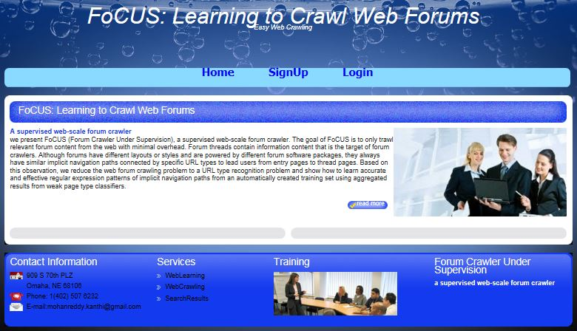

User needs to sign up to have the account created, which enables users to use the web forum crawling services.

Below is the Sign Up page displayed when user clicks sign up button from the above home page.

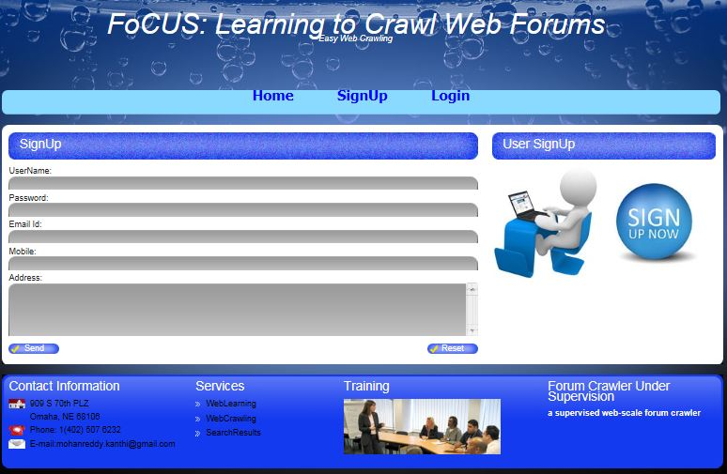

After user got signed up successfully, he should be able to login with the created account and use the web crawling service.
Below is the login page where user enters his account username and password to login to crawl a web forum.
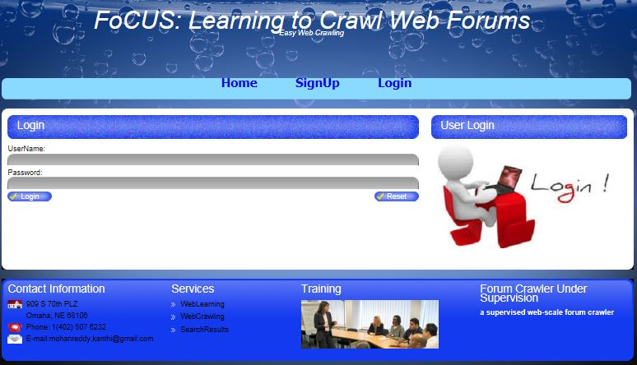

The below screen show the learning tab after user got successfully log in to his account. This screen enables the user to add annotated (approx. 5) to the system to generate regular expression as part of the learning process. The user added forum’s learned regular expressions are only used in the web forum Crawling process later.

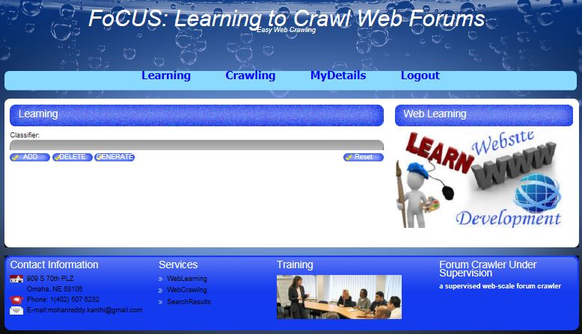

The below screenshot samples with five web forum URL’s added in the table below. The learned regular expression from the given 5 forum URL’s are generated on the right side of the table when user clicks generate button under Classifier field.

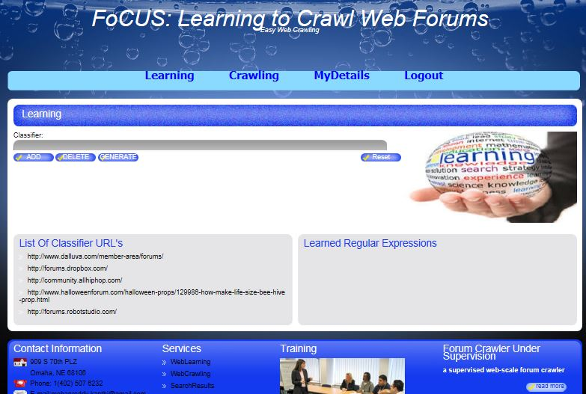

Below is the screenshot of the crawled web forum (http://community.cartalk.com/) with the individual page types are distributed over many pages.
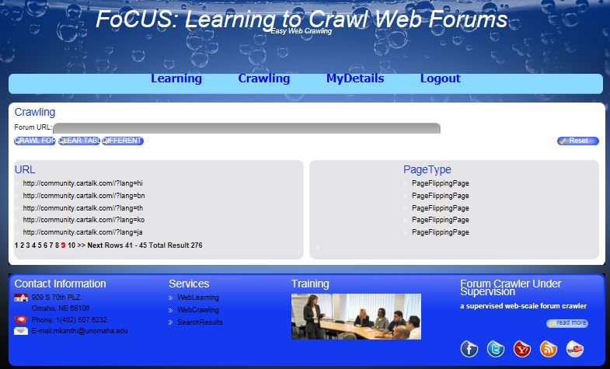

Application Critical Code Module Wise:
Constructing URL Training Set
Training URL’s are identified by following code
In JSP Scriptlet implement the code it is particularly forum URL or Not
<%!
static ArrayList<String> text = new ArrayList<String>();
static ArrayList<ITBean> hyperlink = new ArrayList<ITBean>();
static ArrayList<String> dup = new ArrayList<String>();
static ArrayList<String> forum = new ArrayList<String>();
static String main_url;
static StringBuilder sb = new StringBuilder();
static int start = 0;
static String[] schemes = {"http","https","ftp","file","local","mailto"};
static UrlValidator urlValidator = new UrlValidator(schemes);
static int crawl_size;
static DefaultTableModel dtm;
static String uri;
public static boolean check(String source[],String target[]){
boolean flag = false;
int count = 0;
if(target.length >= source.length){
//if(target[source.length-1].indexOf(source[source.length-1]) != -1){
//target[source.length-1] = target[source.length-1].replace(target[source.length-1],source[source.length-1]);
for(int i=0;i<source.length;i++){
if(source[i].trim().equals(target[i].trim())){
count = count + 1;
}
}
//}
}
if(count == source.length)
flag = true;
return flag;
}
public static String append(String url,String domain){
String s1 = url;
boolean flag = false;
for(int i=0;i<schemes.length;i++){
if(url.startsWith(schemes[i])){
flag = true;
break;
}
}
if(!flag){
if(!url.startsWith("/"))
s1 = domain+url;
if(url.startsWith("/"))
s1 = domain.substring(0,domain.length()-1)+url;
}
return s1;
}

%>

<%

String bt=request.getParameter("bt");
if(bt.equals("GENERATE")){
String url2=request.getParameter("url");
System.out.println(url2);
URL url11 = new URL(url2);
URLConnection urlConnection = url11.openConnection();
HttpURLConnection connection = null;
if(urlConnection instanceof HttpURLConnection)
{
connection = (HttpURLConnection) urlConnection;
}
else
{
out.println("Please enter an HTTP URL.");
return;
}
System.out.println(urlString);

if(urlString.contains("forum")){
Statement ps=con.createStatement();
String reg=url1+"/\\w+/\\d+.html";
ps.executeUpdate("insert into record values("+new Random().nextInt()+",'"+url1+"','"+reg+"')");
response.sendRedirect("learning.jsp");
}else{
response.sendRedirect("mainerr.jsp");
}

Entry URL Discovery
Implemented code of Entry URL detection algorithm and Reaming URL’s page detection
String s1="EntryPage";
String s2="IndexPage";
String s3="ThreadPage";
String s4="PageFlippingPage";
ArrayList entry=new ArrayList();
ArrayList index=new ArrayList();
ArrayList thread=new ArrayList();
ArrayList page1=new ArrayList();
//String url=(String)session.getAttribute("url");
System.out.println(url);
entry.add(url);

ResultSet rs=st.executeQuery("select * from record");
if(rs.next()){
try{
st.executeUpdate("insert into record1 values("+new Random().nextInt(1000)+",'"+url+"','"+s1+"')");
Document doc = Jsoup.connect(url).get();
String title = doc.title();
System.out.println("title is: " + title);
//get all links and recursively call the processPage method
Elements links = doc.select("a[href]");
String text=null;
for (Element link : links) {
System.out.println("Index Page : " + link.attr("href"));
st.executeUpdate("insert into record1 values("+new Random().nextInt(1000)+",'"+url+"/"+link.attr("href")+"','"+s2+"')");
index.add(url+"/"+link.attr("href"));
String urllink=url+"/"+link.attr("href");
System.out.println(urllink);
System.out.println("boolean:" +urllink.startsWith("http"));
if(link.attr("href").startsWith("http://")){
Document doc1 = Jsoup.connect(link.attr("href")).get();
Elements links1 = doc1.select("a[href]");
for (Element link1 : links1) {
System.out.println("Thread Page : " + link1.attr("href"));
st.executeUpdate("insert into record1 values("+new Random().nextInt(1000)+",'"+url+"/"+link1.attr("href")+"','"+s3+"')");
thread.add(url+"/"+link1.attr("href"));
//System.out.println("text : " + link1.text());
if(link1.attr("href").startsWith("http://")){
Document doc2 = Jsoup.connect(link1.attr("href")).get();
Elements links2 = doc2.select("a[href]");
for (Element link2 : links2) {
System.out.println("Page Flipping Page : " +url+"/"+link2.attr("href"));
st.executeUpdate("insert into record1 values("+new Random().nextInt(1000)+",'"+url+"/"+link2.attr("href")+"','"+s4+"')");
page1.add(url+"/"+link2.attr("href"));
//System.out.println("text : " + link.text());
}
}
}
}

}
}catch(Exception e){

}
}else{
out.println("no learning expressions");
}
System.out.println(entry);
System.out.println(index);
System.out.println(thread);
System.out.println(page1);

